Micaela Terry

IML 300

Fall 2019

**I. REFERENCES**

**a. Websites**

1) Choose Your Story - <https://chooseyourstory.com/Default.aspx>

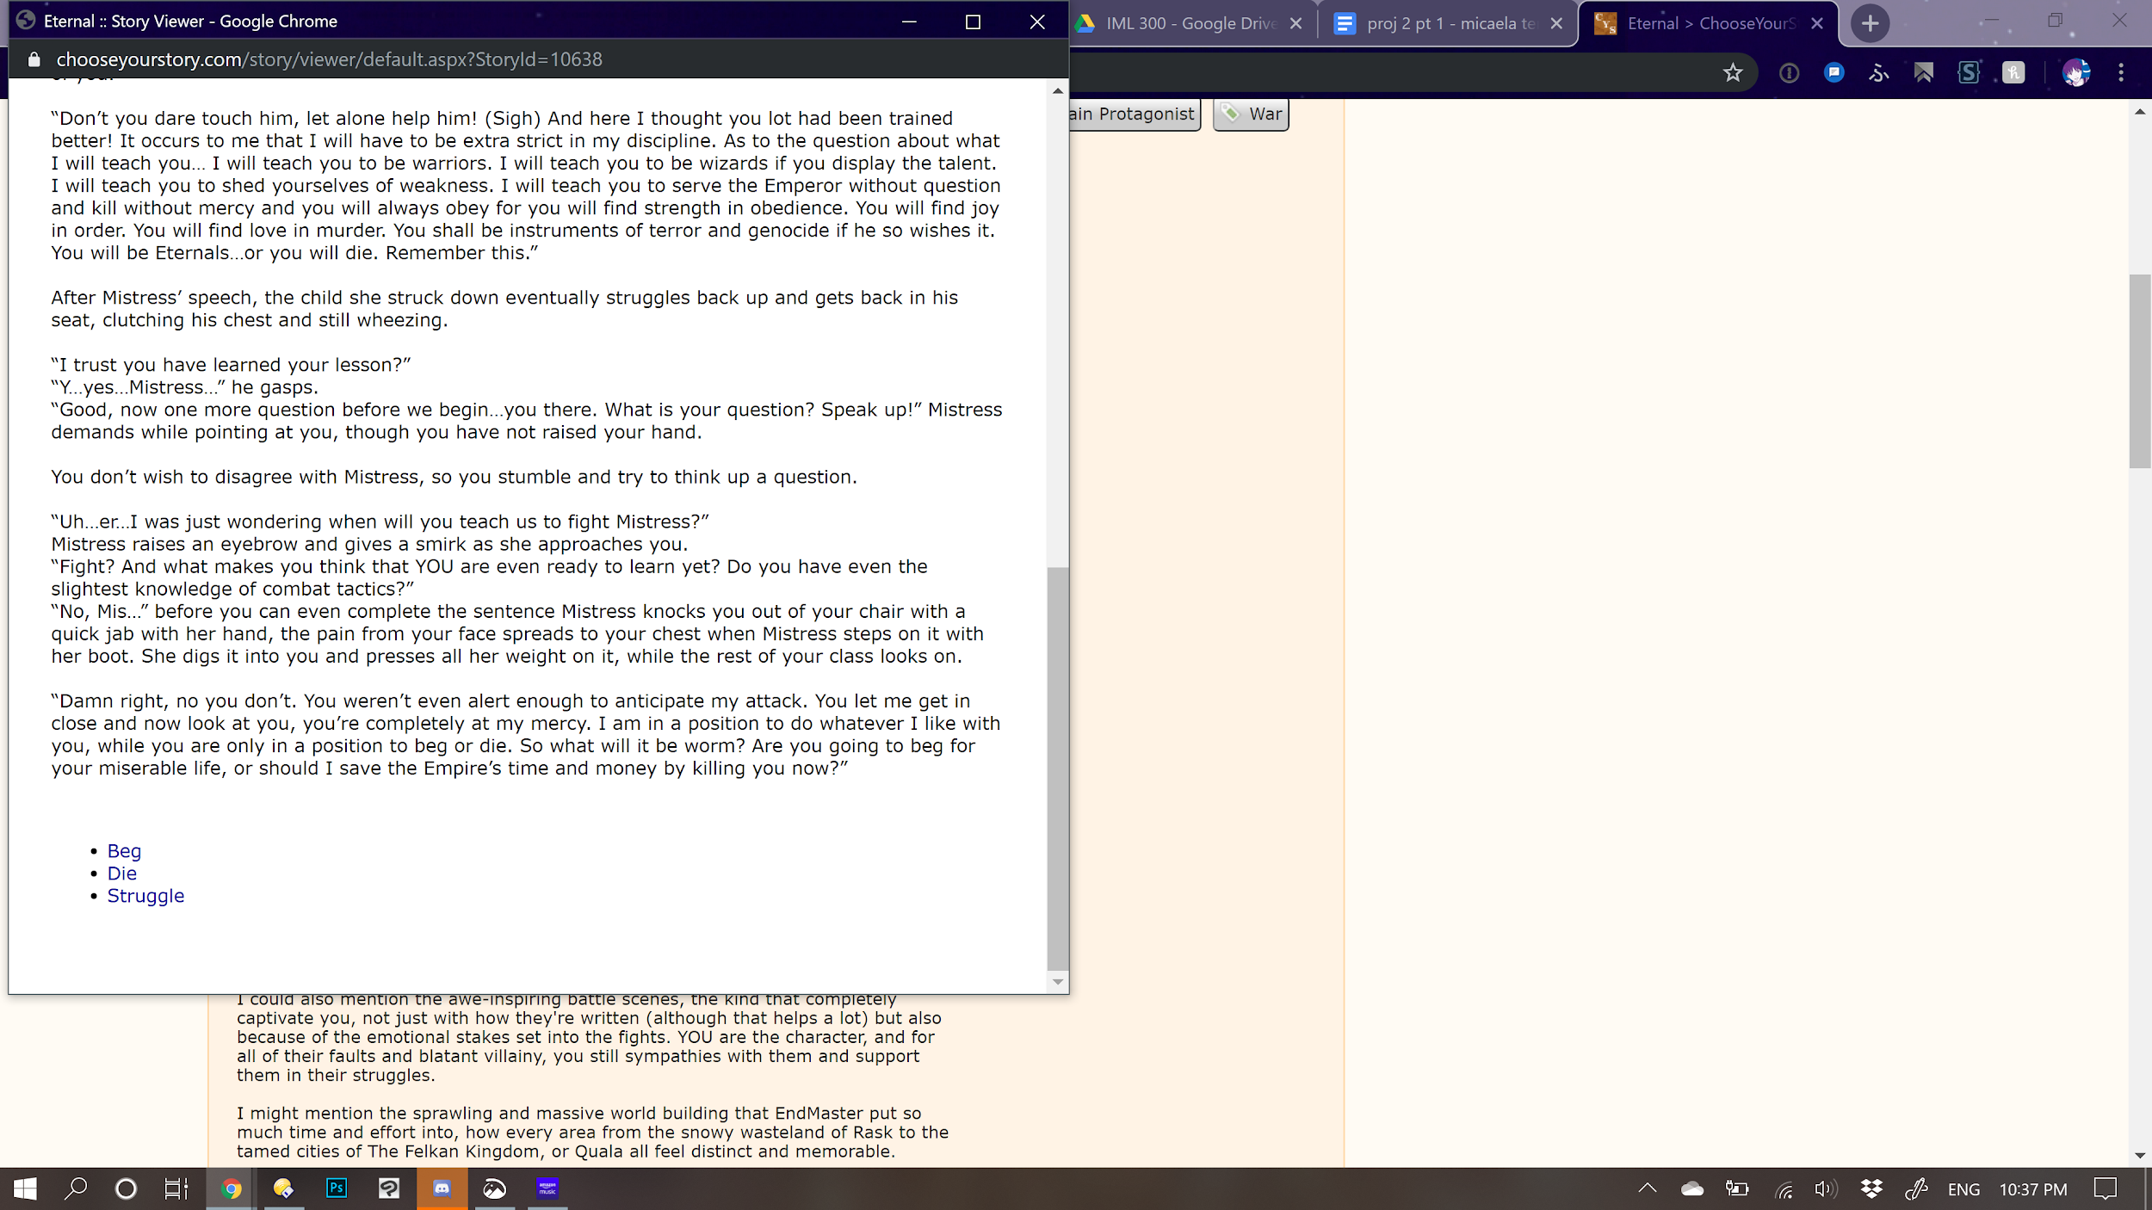

Choose Your Story is functionally what I want my project to do, with choices between actions and / or dialogue that influence the course of the story. It is much more text-heavy than image-based, as opposed to mine which I hope to be more in the style of a visual novel, but its content seems to be created by novice writers and reads like fanfiction, a subculture which I feel is going to inform the nature of this work.

2) *Homestuck* - <https://www.homestuck.com/story/1>

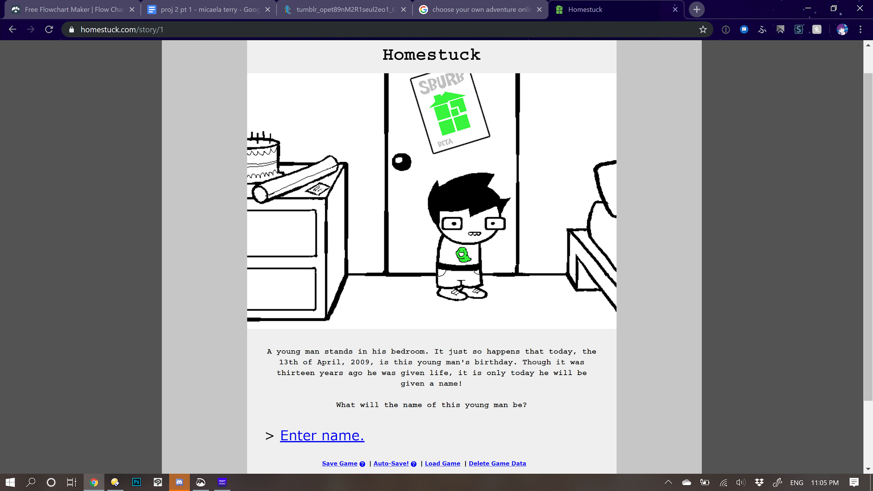 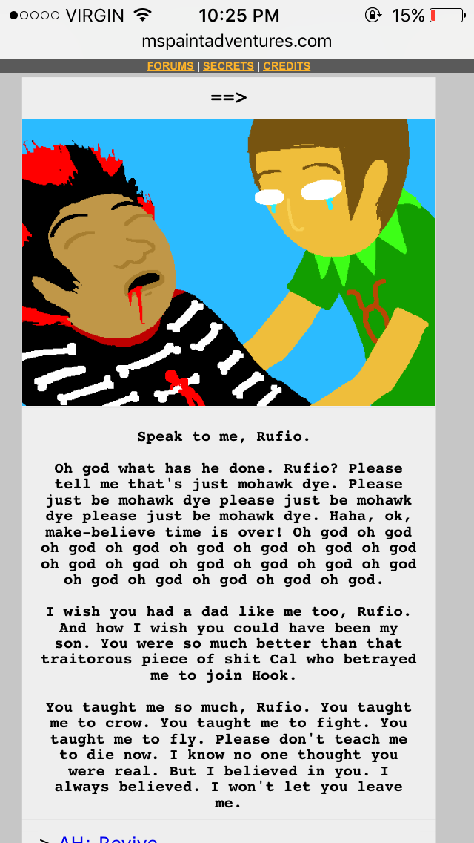

While I’m unfamiliar with the actual plot of *Homestuck,* I was on the internet around the time it was hugely popular, and I do know that it’s an interactive, online story with illustrations and dialogue, in the vein of a visual novel. While I imagine my project will have different style choices in terms of font and color, this is structurally what I envision it looking like.

3) *Neon Genesis Evangelion* Official Site - <https://www.evangelion.co.jp/>

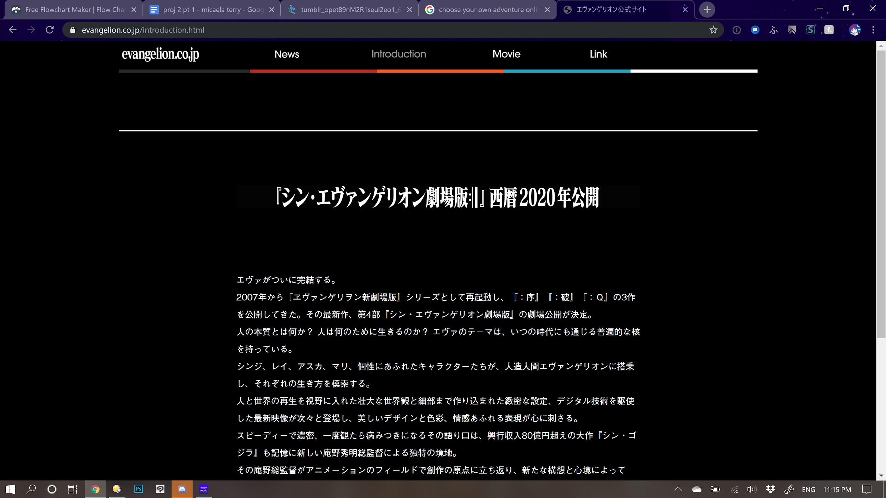

My first two inspirations have been more functional than aesthetic. I want to create a story set in the universe of the anime *Neon Genesis Evangelion* for this project (more on that later), so I find it only natural that I take some aesthetic inspiration from its official media. While the official site is fairly minimalist in terms of layout, I plan to use its colors, fonts, and so forth in some form on my site.

4) Danganronpa: Bursting Love - <https://okabee.itch.io/danganronpa-bursting-love>

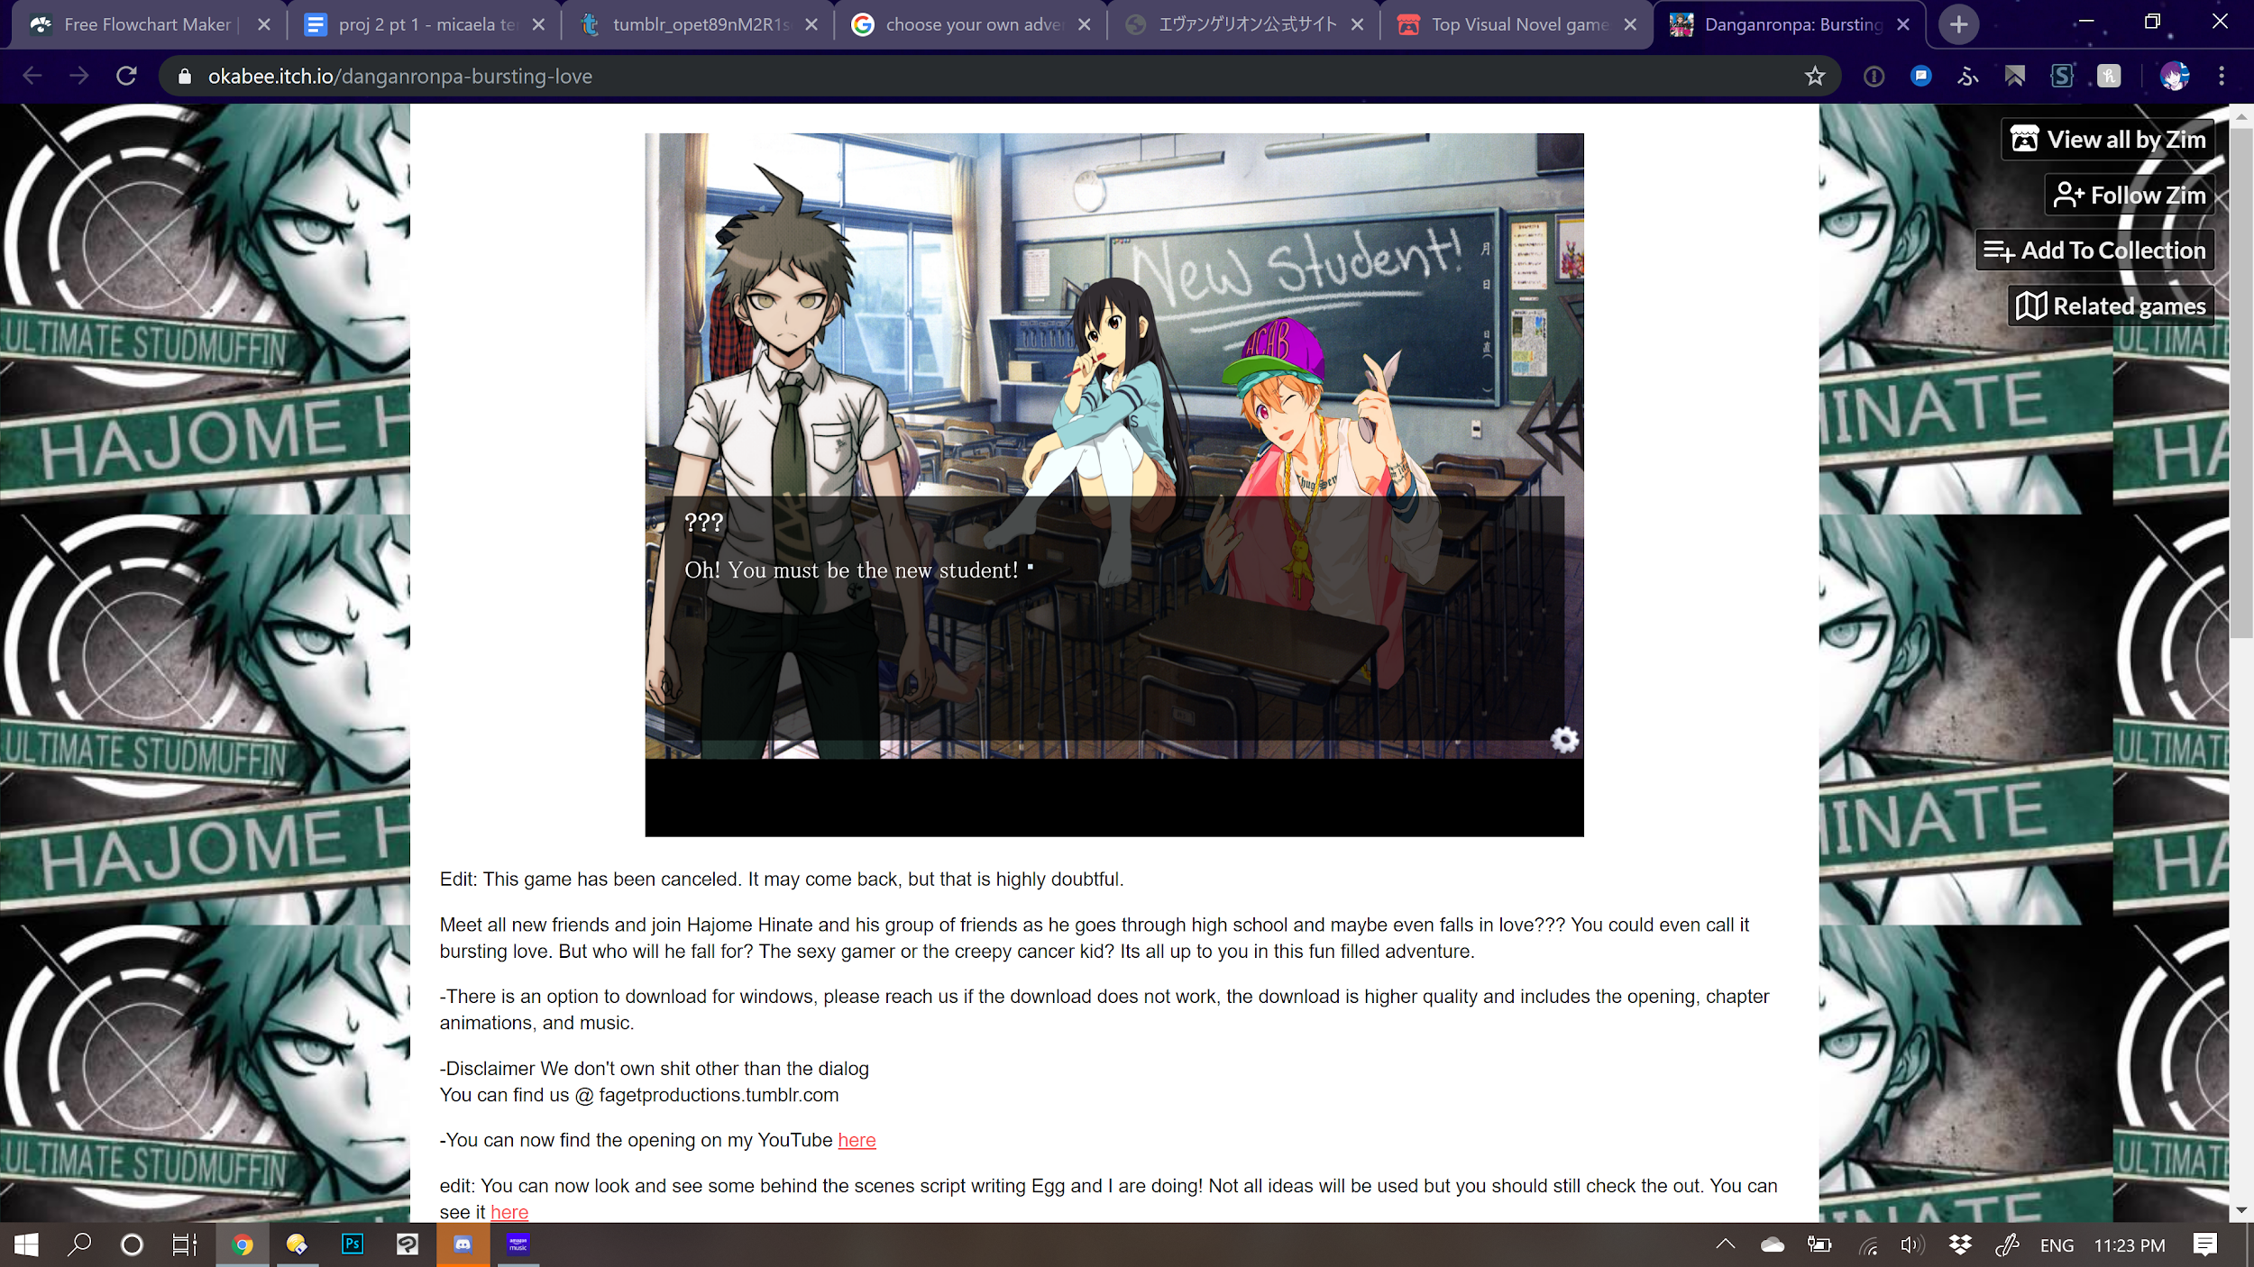

Minus the elements of comedy/parody, this work is pretty much in the vein of what I would like to do for this project. It’s a fangame which adapts material from an existing story (per the assignment prompt), uses some of its assets, and runs on the web. I will most likely take a page from its book and have the game take up most of the window, with a non-distracting background and some navigation at the bottom.

**b. Artwork**

1) *Neon Genesis Evangelion: Girlfriend of Steel 2nd*

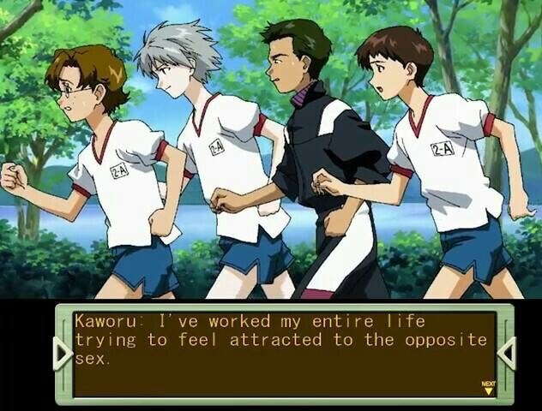 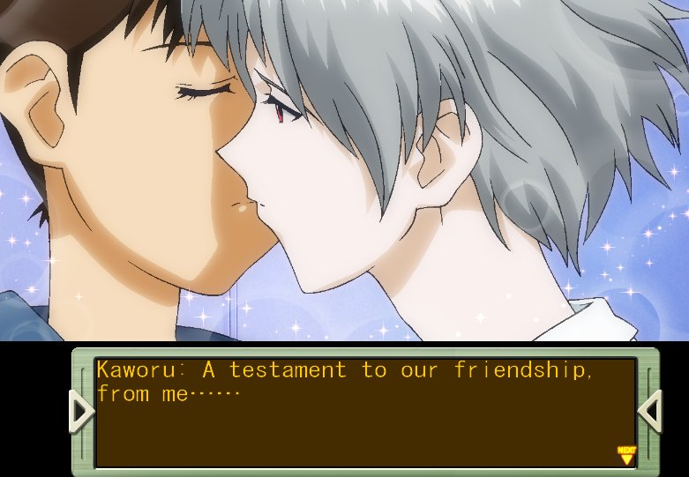

This is a spinoff game based on *Neon Genesis Evangelion,* the story I hope to adapt (loosely) for the project. The *Girlfriend of Steel* games are visual novels with elements that emulate dating simulators. My friends’ and my biggest gripe with *Girlfriend of Steel* and *2nd* is the way the writing shies away from the protagonist, Shinji’s, bisexuality, with only one potential male romantic interest who is continually referred to as a “friend” despite overt LGBT scenes. This will tie into the concept for the project.

2) Dream Daddy

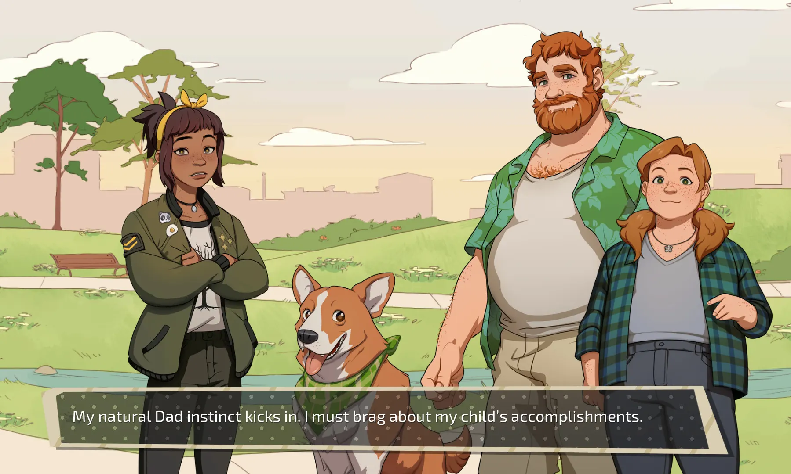

A game which also falls within the dating simulator genre (more explicitly so than *Girlfriend of Steel*), and explicitly features dads trying to date other dads. I’m hoping to model this game after Dream Daddy’s diversity and unabashedly LGBT themes.

**II. CONCEPT**

The concept for this project is actually one that I’ve had with some friends for a while, and I want to use this opportunity to create a sort of demo / proof of concept for it. Seeing as the assignment is to adapt an existing story into an interactive, nonlinear narrative, I figured a fanmade dating simulator for an existing property fit the bill. My friends and I all met through our shared love of *Neon Genesis Evangelion,* a mecha / psychological horror anime which is considered widely to be a cultural landmark. While not the central focus of the story, *Evangelion* features a lot of sexual / romantic tension between its characters as part of its themes of growing up, connecting with others, and what it means to be human. Famously, towards the end of the series, Kaworu is introduced, a boy around the protagonist Shinji’s age, and says that he loves him. At the end of the episode (without spoilers), Shinji says that the feelings are mutual. However, homophobia within the community has led to a lot of fighting over whether Kaworu and Shinji were intended to be lovers, especially in lieu of recent materials being released which shy away from translations like “love.”

While the core *Evangelion* TV series is a scathing critique of escapism and misogyny in the anime subculture, its marketing unfortunately falls into the same pitfalls that the original show critiques, objectifying its female characters and, indeed, selling them as ideal figures to be romanced. The idea for this fan game came about during a discussion of the *Girlfriend of Steel* games, where you control Shinji and can romance several of the female characters. Your options range from heteronormative at best to actively unhealthy for Shinji at worst. Kaworu is the only male romantic candidate, but his actions often get the “no homo” treatment with words like “friendship,” unlike his female counterparts. My friends and I, all LGBT and frustrated with this heteronormativity, decided we wanted to make a fangame where not only is Kaworu an explicit romantic option, but so are the other boys Shinji’s age, who appear in the main storyline but only as side characters and never as romantic interests. For this assignment, I hope to make a demo version of this game, called “Boyfriend of Steel” as of now, which will cycle through one in-game day and allow the player to interact with one of the romantic options, which will end in either increased or decreased affection for the player from the character they encounter.

**III. DIAGRAM**

